ONEWAY CRT BY RES
/STATISTICS DESCRIPTIVES HOMOGENEITY WELCH
/PLOT MEANS
/MISSING ANALYSIS.

Oneway

Notes
Output Created |  | 06-May-2019 00:02:59
Comments
Input | Active Dataset | DataSet0
Input | Filter | <none>
Input | Weight | <none>
Input | Split File | <none>
Input | N of Rows in Working Data File | 30
Missing Value Handling | Definition of Missing | User-defined missing values are treated as missing.
Missing Value Handling | Cases Used | Statistics for each analysis are based on cases with no missing data for any variable in the analysis.
Syntax |  | ONEWAY CRT BY RES  /STATISTICS DESCRIPTIVES HOMOGENEITY WELCH  /PLOT MEANS  /MISSING ANALYSIS.
Resources | Processor Time | 00 00:00:00.172
Resources | Elapsed Time | 00 00:00:00.172

[DataSet0]

Descriptives
 | N | Mean | Std. Deviation | Std. Error | 95% Confidence Interval for Mean
 |  |  |  |  | Lower Bound | Upper Bound
1360x768 | 7 | 6.8000 | 1.82939 | .69144 | 5.1081 | 8.4919
1920x1080 | 15 | 9.2733 | 3.60525 | .93087 | 7.2768 | 11.2699
800x600 | 8 | 9.0500 | 3.52744 | 1.24714 | 6.1010 | 11.9990
Total | 30 | 8.6367 | 3.32291 | .60668 | 7.3959 | 9.8775

Descriptives
 | Minimum | Maximum
1360x768 | 4.40 | 9.40
1920x1080 | 3.20 | 14.00
800x600 | 3.80 | 13.20
Total | 3.20 | 14.00

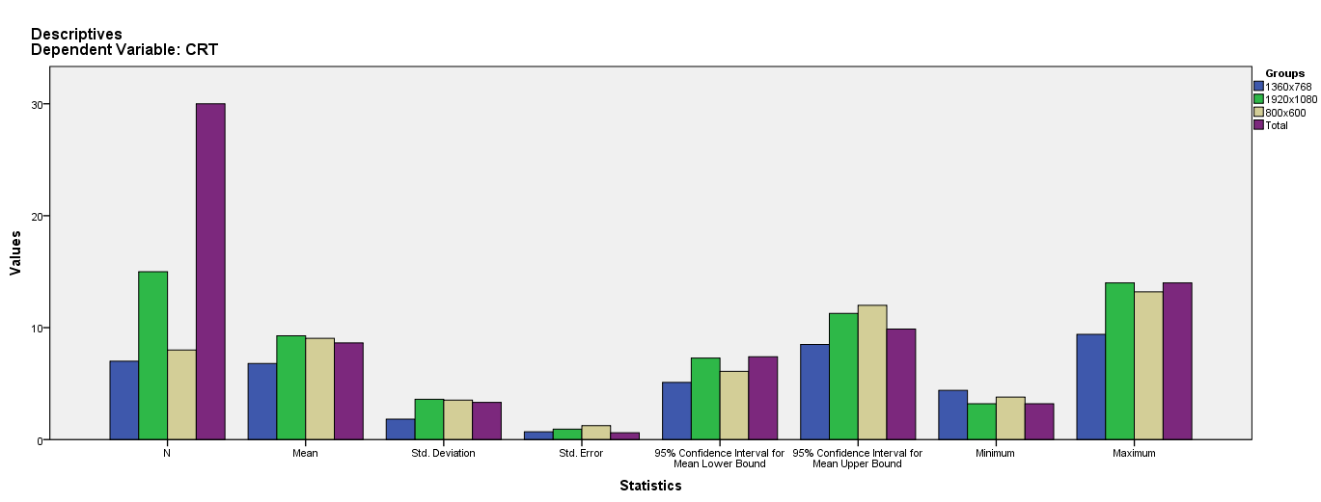

Test of Homogeneity of Variances
CRT
Levene Statistic | df1 | df2 | Sig.
2.668 | 2 | 27 | .088

ANOVA
CRT
 | Sum of Squares | df | Mean Square | F | Sig.
Between Groups | 31.060 | 2 | 15.530 | 1.450 | .252
Within Groups | 289.149 | 27 | 10.709
Total | 320.210 | 29

Robust Tests of Equality of Means
CRT
 | Statisticª | df1 | df2 | Sig.
Welch | 2.665 | 2 | 15.646 | .101
a. Asymptotically F distributed.

Means Plots

